Lesson 7

Matrices and Determinants

SPECIFIC OBJECTIVES:

At the end of the lesson, the student is expected to be able to:

- Define matrix
- Identify different types of matrices.
- Perform operations on matrices.
- Define determinant of a square matrix.
- Evaluate determinant of a square matrix.

7.1 Matrix

Definition 7.1.1 Matrix
A matrix of order mxn is a rectangular array of numbers consisting of elements arranged in m-rows and n-columns.

Remarks:

1. A matrix can be represented by:
  - an upper-case letter such as A, B and C or with subscript such as 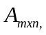 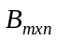 and 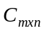;
  - a representative element enclosed in brackets such as 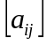, 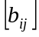 and 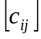.
  - a rectangular array of numbers, 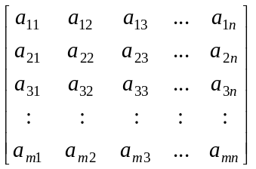

- Two matrices are equal if and only if their orders are equal and corresponding elements are equal.
- A square matrix is one where the number of rows is equal to the number of columns.
- A matrix with only one row is a row matrix while that with only one column is a column matrix.
- An identity matrix is a square matrix where the elements in the main diagonal are all 1’s and the other elements are 0’s.
- A zero matrix is one where all elements are zero.
- A diagonal matrix is a square matrix with off-main diagonal entries all zeros.
8. A zero-one matrix is a matrix consisting of zeros and ones only as entries.
- The transpose of a matrix , denoted by A^{T} , is obtained by interchanging the rows and columns of the matrix.

Example 7.1.1 State the order and find the transpose of each of the following
matrices:

a. 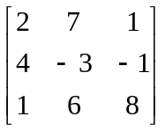 b. 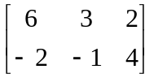 c. 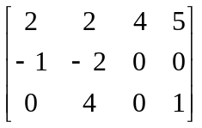

d. 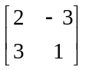 e. 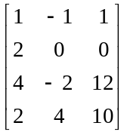 f. 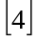

g. 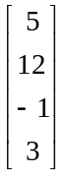 h. 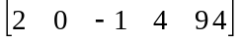

Example 7.1.2 For each of the matrix given in example 7.1.1, identify the
following elements:

a. 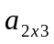 b. 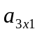 c. 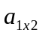 d. 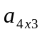

Example 7.1.3 Find the values of a, b, c, and d so that each of the given
statements would be true:

a. 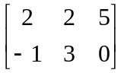 = 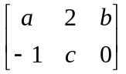 b. 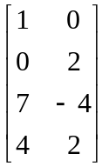 = 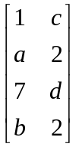

Example 7.1.4 Identify the type of matrix given by each of the following:

a. 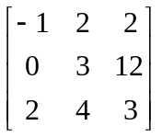 b. 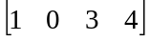

c. 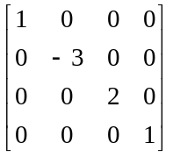 d. 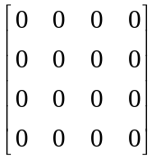

e. 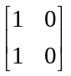 f. 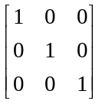

Example 7.1.5 Find matrix X that will make the given statement true.

- X - 3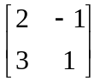 = 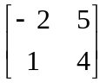 b. –3X - 4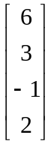 = 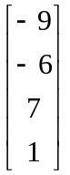

Exercise 7.1.1 Solve for X such that each of the following statements is true:

a) 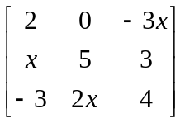 = 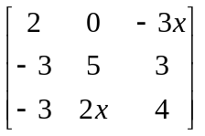

b) 2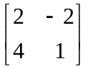 - X = 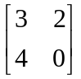

c) 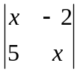 = 14

d) 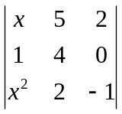 = -3
7.2 Operations on Matrices

Definition 7.2.1 Matrix Addition

The sum of m x n matrices 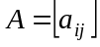 and 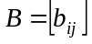 is an m x n matrix defined by

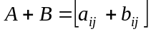
This means we can add two matrices of the same order by adding their corresponding entries.

Remark:
The sum of two matrices of different orders is not defined.

Definition 7.2.2 Matrix Scalar Multiplication

The product of a scalar (real) number c and an m x n matrix is an m x n matrix defined by

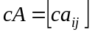

Remark:

Properties of Matrix Addition and Scalar Multiplication

If A, B, C and O (zero matrix) are m x n matrices and c and d are scalar numbers, then the following hold true.

1. A + B = B + A Commutative Property of Addition
2. A + (B + C) = (A + B) + C Associative Property of Addition
3. cdA = c(dA) Associative Property of Scalar
Multiplication
4. IA = A Scalar Identity
5. c(A + B) = cA + cB Distributive Property
6. (c +d) A = cA + dA Distributive Property
7. A + O = A Identity Property of Addition

Note: The difference A – B = A + (-B)

Example 7.2.1 Given the following matrices:

A = 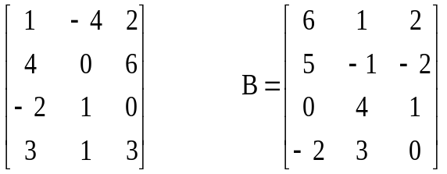 C = 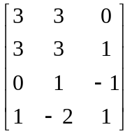

Evaluate the matrix required for. If the matrix asked is not possible, state so.
- 3A d. 4(A-B+C)
- C-2B e. (2B+C)^{T}
- (A+B)+3C f. (5C-3A)^{T}

Definition 7.2.3 Matrix Multiplication

The product of an m x p matrix 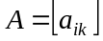 and a p x n matrix 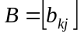 is an m x n matrix 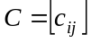 defined by

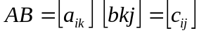

where 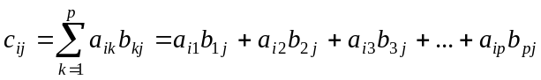.

Properties of Matrix Multiplication

If A, B, C, and I (identity matrix) are matrices such that all of them have defined sums and products, then the following properties hold true.
1. A(BC) = (AB)C Associative Property of Multiplication
2. A(B+C) = (AB+AC) Left Distributive
3. (A+B)C=(AC+BC) Right Distributive
4. c(AB)=(cA)B=A(cB) Distributive Property
5. AI=A Identity Property of Multiplication

Example 7.2.2 Given the following matrices:

A = 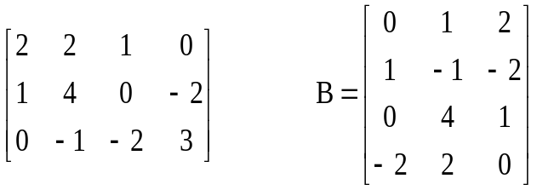 C = 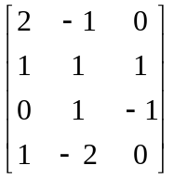

- Evaluate each of the following. If the matrix asked for is not possible, state so.

  - AB e. (2A)B
  - BA f. (AB)C
  - (AB)+C g. IC
  - A(BC)

- Verify each of the following statements:

a. (2A)^{T} = 2(A)^{T}
- (3A)B = A(3B)
- (A^{T})² = (A²)^{T}
- (AB)^{T} = A^{T} B^{T}

Definition 7.2.4 Matrix Row -Echelon Form and Reduced Row-Echelon Form
A matrix is said to be in row-echelon-form if the following properties hold:
1. All rows consisting entirely of zeros are found below all rows that do not consist entirely of zeros.
2. Any row that does not consist entirely of zeros must have the first nonzero entry 1 (called a leading 1).
3. For any two successive nonzero rows, the leading 1 in the higher row is farther to the left than the leading 1 in the lower row.

A matrix in row-echelon form is in reduced row-echelon form if every column that has a leading 1 has zeros in every position above and below it.

Example7.2.3 Which of the following matrices are in the row-echelon form?

a) 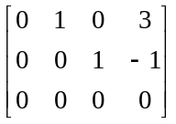 b) 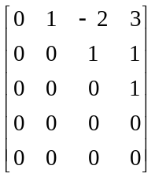 c) 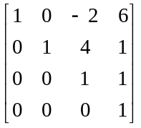

d) 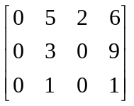 e) 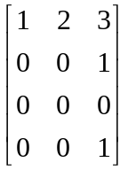

Exercise 7.1.2 Given the following matrices:

A = 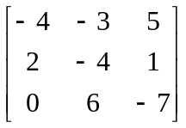 B = 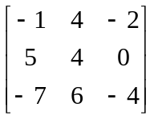 C = 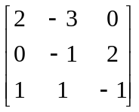

Verify the following statements:

  - (A+3B)+C = A + (3B+C)

  - AI = A

  - (4B)^{T} = 4(B)^{T}

  - (2A)C = A(2C)

  - (AB)C = A(BC)

7.3 Determinat

Definition 7.3.1 Determinant

The determinant of a matrix is a number assigned to every square matrix. The determinant of a matrix A is denoted by det(A) or 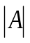.
For a 2x2 matrix, the determinant is defined as:

= 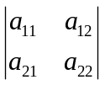 = 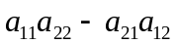.

For a 3x3 matrix, the determinant is:

= 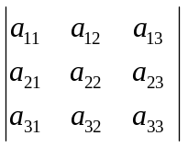

=

For any square matrix of order n>=3, the determinant can be evaluated using:

a) Co-factor Expansion about a column:
= 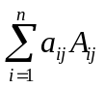 for all i, for a given j
b) Co-factor Expansion about a row:
= 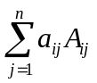 for all j, for a given i ,
where
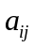 is the element in the ith-jth position
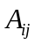 is the cofactor of .

Definition 7.3.2 Minor and Cofactor of an Element :

The minor, 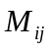, of an element is the determinant of the matrix that remains after deleting the ith row and jth column in which the element lies.
The cofactor of the element is the minor preceded by a positive sign if (i+j) is even and negative if (i+j) is odd. That is,

= 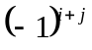

Remarks:

Properties of Determinants

- The determinant of a matrix and its transpose are equal.
- If two rows (columns) of a determinant are interchanged, the value of the resulting determinant is the negative of the given determinant.
- If two rows (columns) of a determinant are identical, the determinant is zero.
- If the elements of a row (column) of a determinant is multiplied by a scalar quantity k , the resulting determinant is k times the given determinant.
- The value of the determinant is not changed if a row (column) is replaced by that row plus a multiple of another.

Example 7.3.1 Evaluate the following determinants ( use the properties
whenever possible):

a) 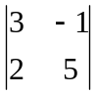 b) 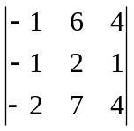 c) 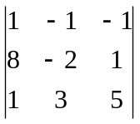

d) 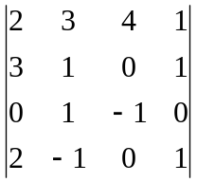
Ans. a. 17
- -1
- 0
- 8

Example 7.3.2 Solve for X to make the statement true:

a. 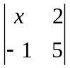 = 7 b. 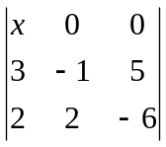 = 8 c. 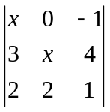 = 10

Ans. a. x = 1
- x = -2
- x = 8, -2

Example 7.3.3 Verify the following statements:

a. 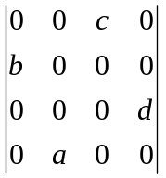 = -bacd b. 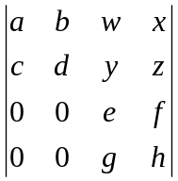 = 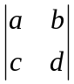 . 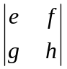

c. 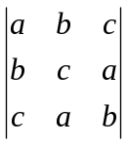 = (a+b+c)(ab + bc + ca - a² - b² - c² )

Exercise 7.3.1 Determine each of the following determinant .

a) 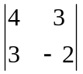 b) 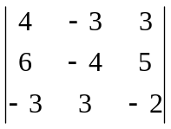 c) 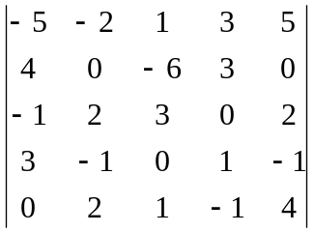

d) 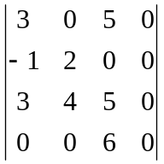 e) 